Task 7

1. Chat GPT

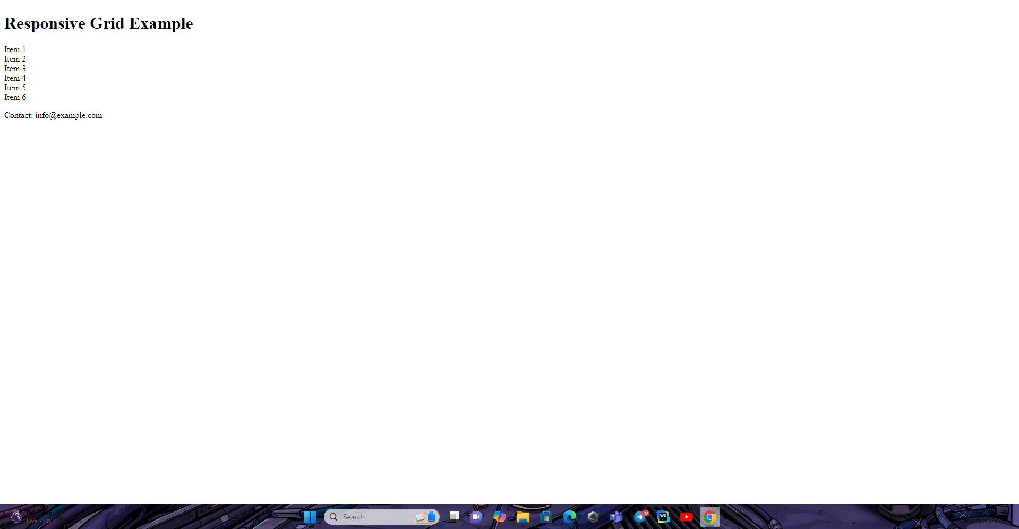

2. Gemini doesn’t match with HTML

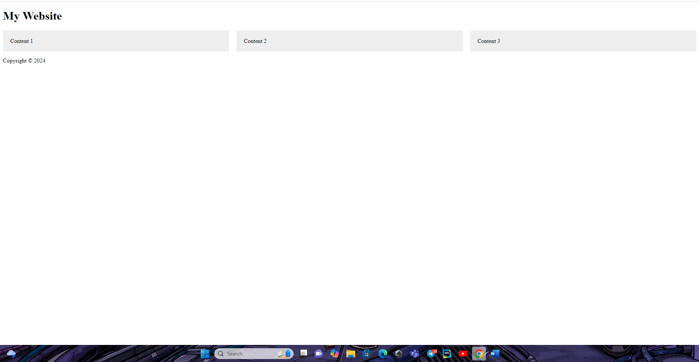

Gemini is better